Michael Meli

ECE 561

Spring 2015

Project 1

**Architecture Diagrams**

Original TSS Application

Project 1

**Sequence Diagrams**

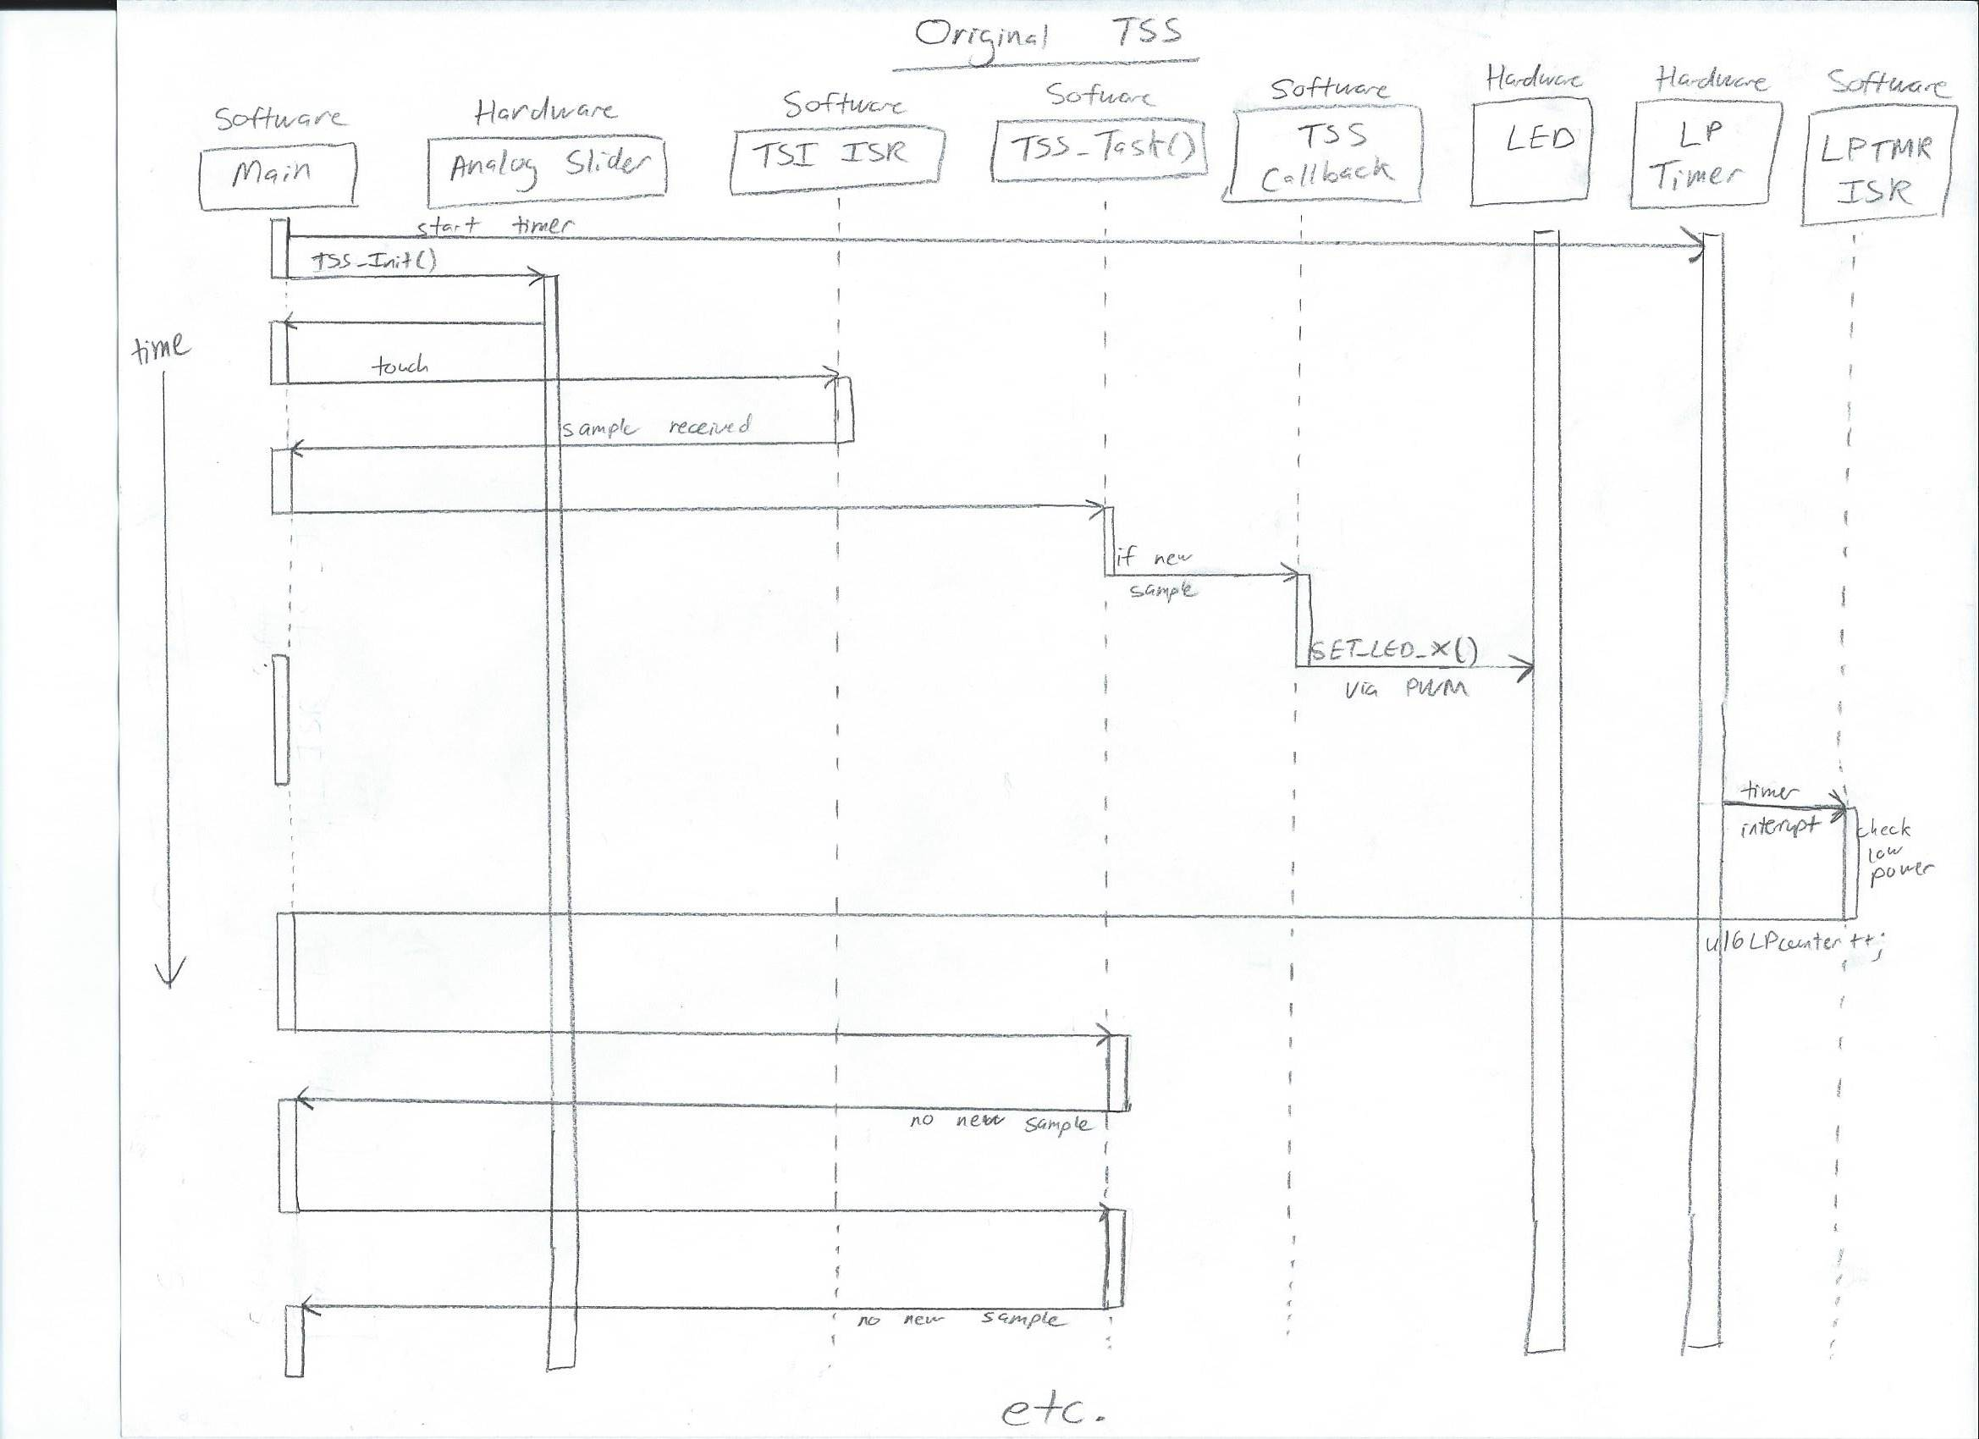

Original TSS Project

Project 1 – Touch Slider

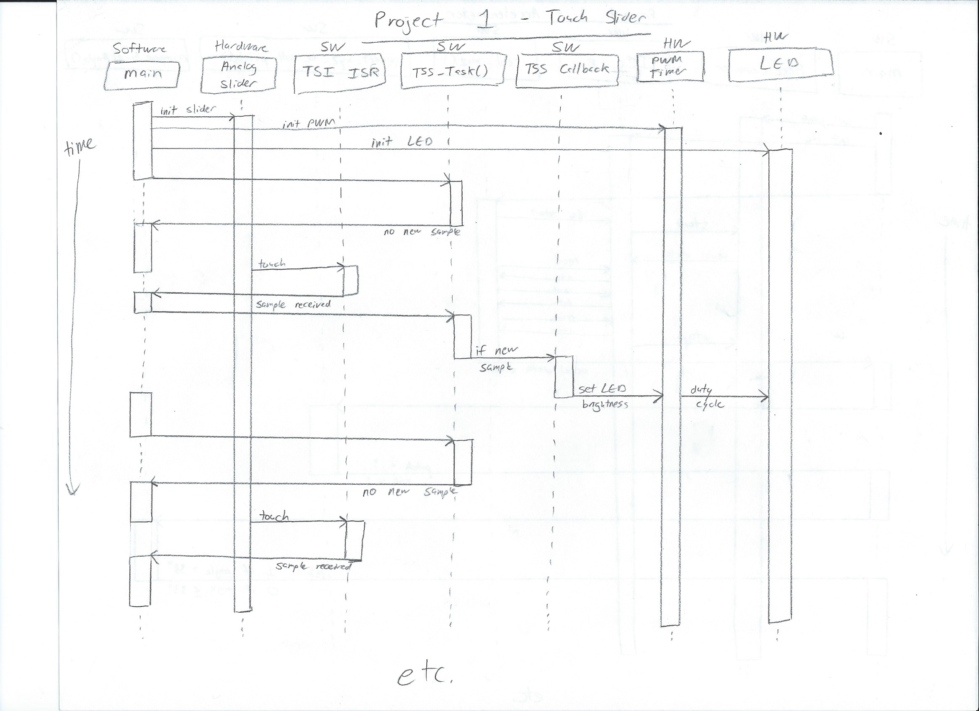

Project 1 – Accelerometer

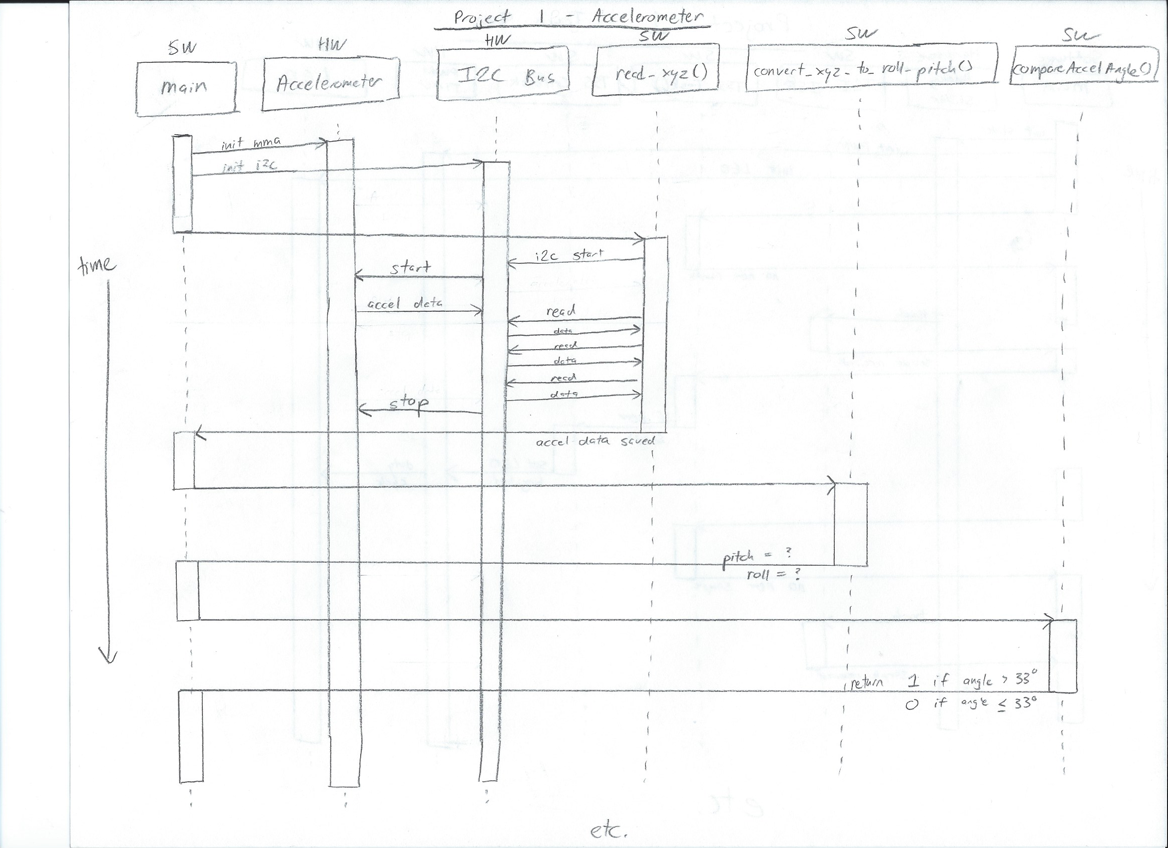

Project 1 – PIT and ADC

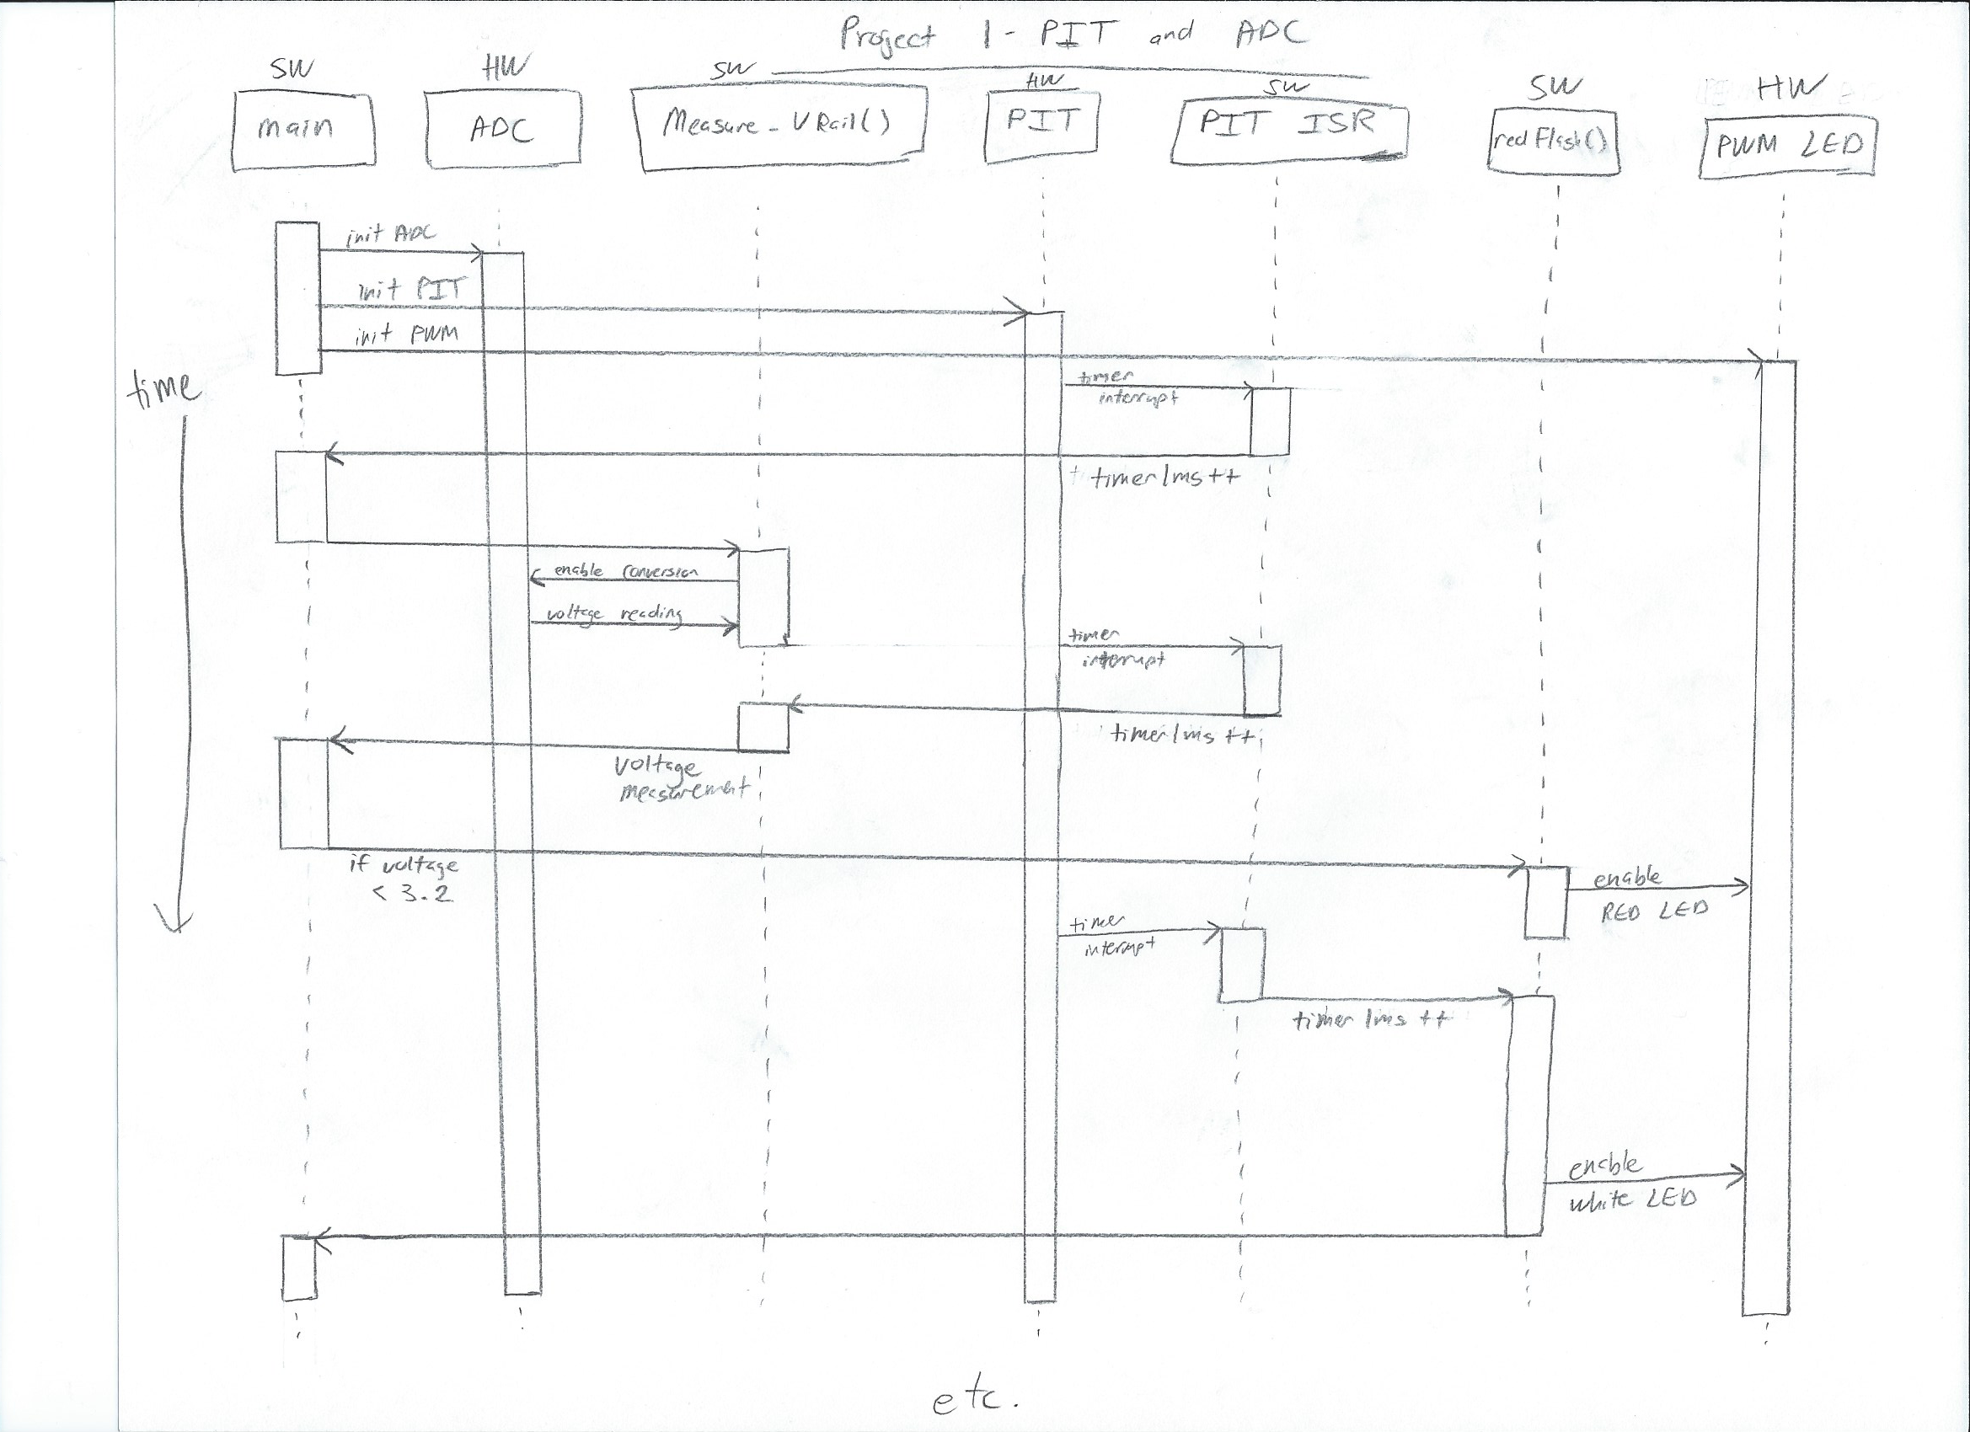

**Development Effort**

Estimated: 20 hours

Actual: 13 hours

I expected it would be more difficult to figure out how to use the peripherals than it was. The sample code simplified things significantly.